This document describes the verification guide for the changes done during the **JOHN HANCOCK - PROJECT COEUS ADMIN FRONTEND ASSEMBLY PART 2** challenge.

1. Make sure you have deployed the application correctly following the “Deployment Guide.md” at root folder
2. Make sure you have inserted test data using **\TestFiles\TestData.sql**
3. Login with admin, if you have followed user creation from deployment guide, username= CoeusAdminUser and password=password
4. Go to **Edit Fields** menu and “**Global Fields**” tab, the page should as below

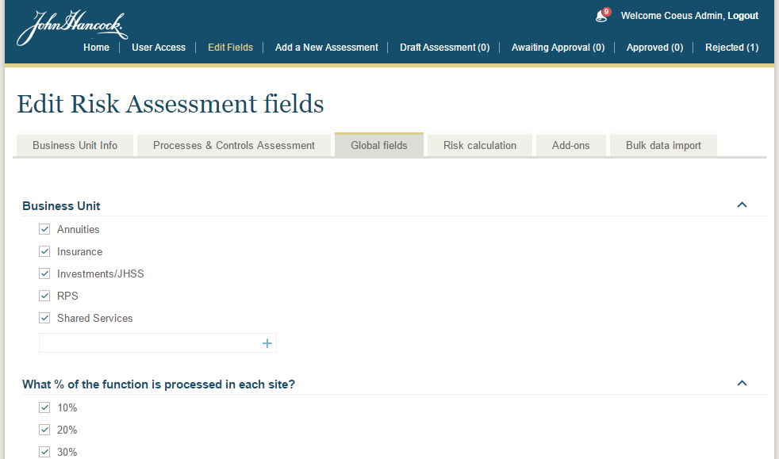

Verify following

* The checkbox is used to enable/disable the item
* Each item can be sorted within its group by dragging
* Verify new item creation
* Verify update
* Verify delete
* Verify collapse/expand of group

1. Go to “Risk Calculation” tab you will see similar page

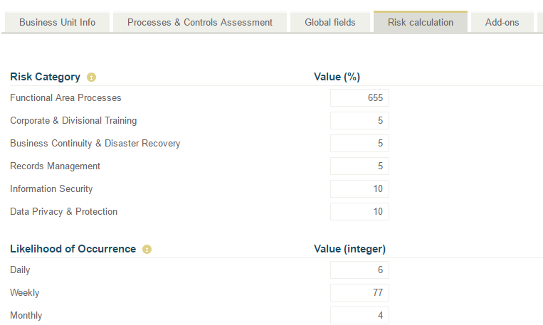

Verify following

* Verify value can be updated for each item
* You have to change the value and **press “Enter” key** to update the changes. Changes will be saved if valid value.

1. Go to “Add Ons” tab and you might get empty page (if you have not created any add ons yet).

To create add ons see below section “**9 Add On Creation**”. Once you create add ons you can see page similar to below

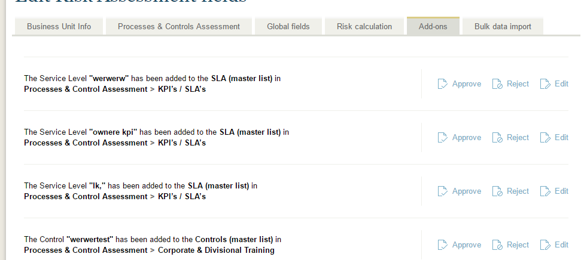

Verify following

* Click approve link to approve.
* Click reject link to reject
* Click Edit icon to start the editing. On edit mode you will see

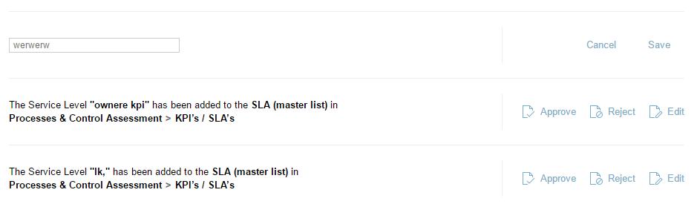

Change the value in text box and click save link or click cancel to cancel the edit.

1. To verify **Notification**

If you have any pending add ons you can see the notification counts and open the details as shown in below

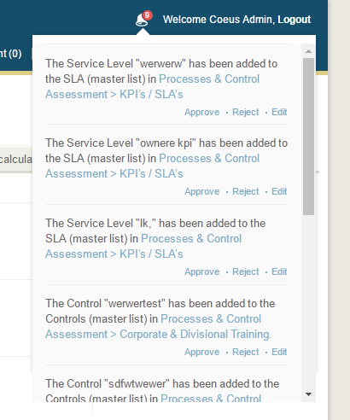

* Verify “Approve”, “Reject” and “Edit” which is similar to “Add Ons” tab
* Verify link which should redirect you to the respective section in which the add ons will be added after approved

1. Charts Verifications (login with owner user, otherwise you might be not able to edit the existing assessments from admin, however you can create new assessments and see the details)

8.1. To verify charts, go to assessment detail, e.g. navigate to #/assessmentDetails/1, you will see similar chart (the data may be different for you)

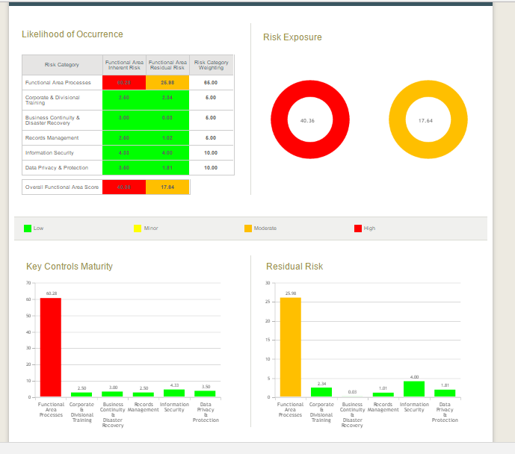

8.2. To verify in add assessment page, login with either owner or admin and go to the Add assessment page by clicking “Add a New Assessment” menu.

- Select the business unit and functional area and create some assessments and go the “Overall Risk Rating” tab. You will see the charts similar to above based on your assessments data.

8.3 To verify in edit assessment page, create an assessment as draft and open the assessment in edit mode and verify the charts.

1. **Add On Creation**

To create add on either login with owner or admin and go to add/edit assessment page then you can create new add on in following section

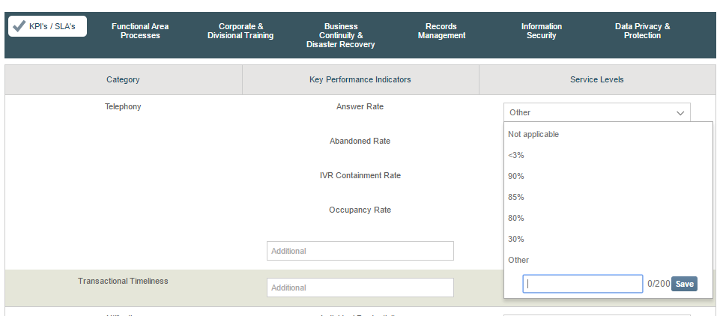

And in “Controls” dropdown of other category tabs

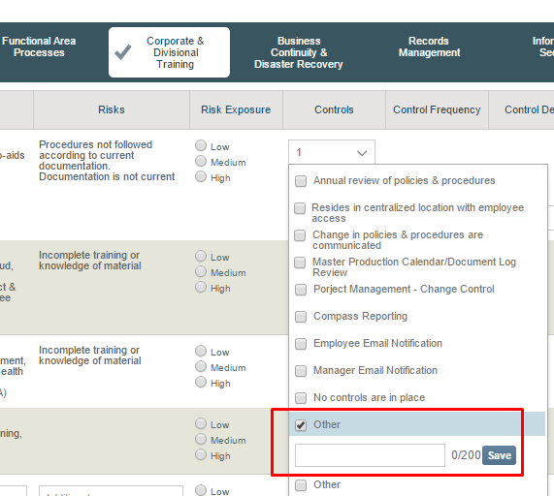

Note: You have to click the “Save” button to create add on, otherwise, the Add on won’t be created but you can still add the other item for this assessment without submitting for approval to make it default.

1. **Verify Global option**

* Login with Admin
* Create “Global” KPICategory, CoreProcess and Process in “Edit fields” page as shown in example below

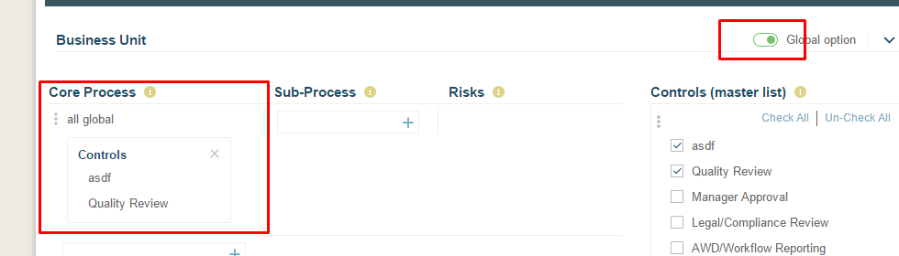

* Create few business unit wise global KPICategory, CoreProcess and Process

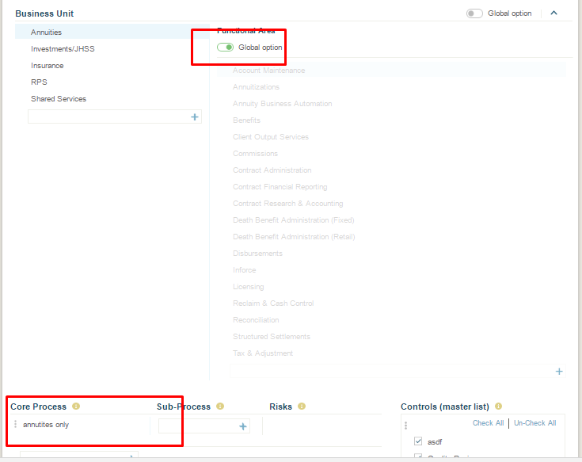

* Now, go to add assessment page, and without selecting any business unit or functional area unit you should see the global items.
* Similarly select the business unit only for which you have created item for the business unit wise, you will see those KPICategory/coreProcesses and process are also added to the global items.